**Exercise No:3**

**Date:14-10-2020**

**Aim:**

**To remove and print every second number from a list of numbers until the list becomes empty using python.**

**Program:**

**def removeThirdNumber(lst):**

**lst1=[]**

**pos=1**

**s=0**

**for i in range (0,len(lst)):**

**s=(pos+s)%len(lst)**

**e1=lst.pop(s)**

**lst1.append(e1)**

**return lst1**

**n=int(input("enter number of elements"))**

**int_list=[]**

**for i in range(0,n):**

**e=int(input())**

**int_list.append(e)**

**p=removeThirdNumber(int_list)**

**print(p)**

**Output:**

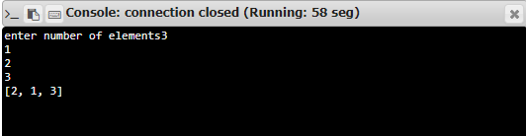

**Result:**

**Thus, number removed and printed successfully every second number from a list of numbers until the list becomes empty using python.**